MySQL DROP Database

We can drop/delete/remove a MySQL database quickly with the MySQL DROP DATABASE command. It will delete the database along with all the tables, indexes, and constraints permanently. Therefore, we should have to be very careful while removing the database in MySQL because we will lose all the data available in the database. If the database is not available in the MySQL server, the DROP DATABASE statement throws an error.

MySQL allows us to drop/delete/remove a database mainly in two ways:
1) MySQL Command Line Client
2) MySQL Workbench

1) MySQL Command Line Client :
We can drop an existing database in MySQL by using the DROP DATABASE statement with the below syntax:
DROP DATABASE [IF EXISTS] database_name;

use the SHOW DATABASES statement to see all available database in the server:

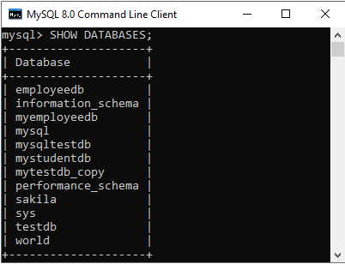

DROP DATABASE mytestdb_copy;

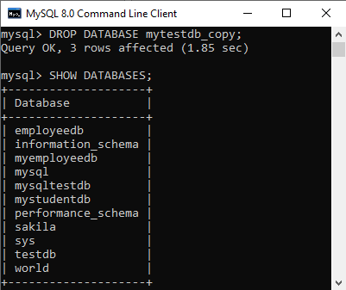

DROP Database using MySQL Workbench :

To drop a database using this tool, we first need to launch the MySQL Workbench and log in with the username and password to the MySQL server. It will show the following screen:

........

